**Task 4**

**Prototype User Interface**

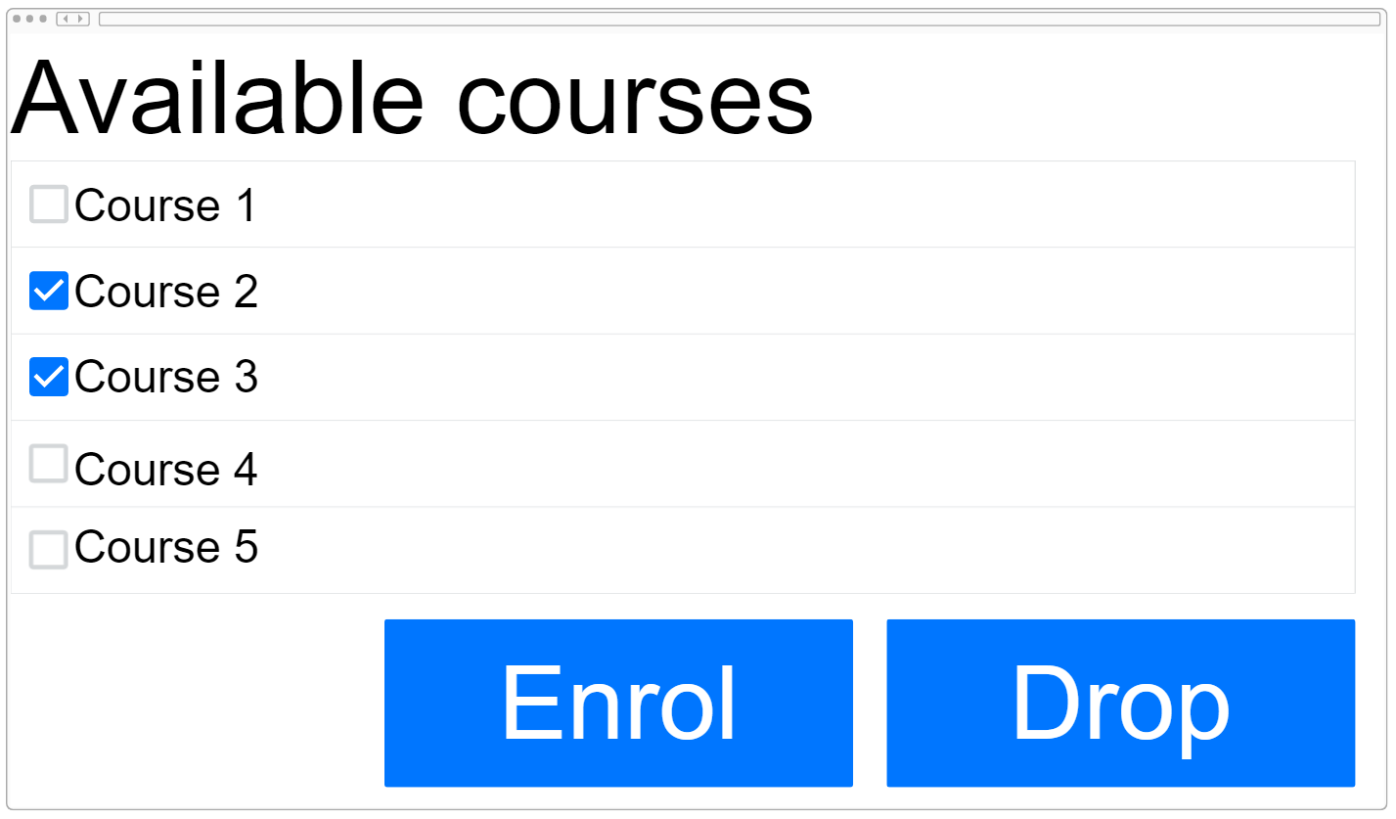

**Usability Testing**

|  |  |  |  |
| --- | --- | --- | --- |
| **Scenario** | **Test Description** | **Task** | **Expected Outcome** |
| Creating a new profile | Evaluate the ease of creating a new profile using a student email and password | Create a new user profile using your student email and a password of your choice | The user should be able to successfully create a new profile using their student email and password without encountering any difficulties |
| Validating student email | Test the validation of the student email during profile creation | Attempt to create a new profile using an invalid email format or a non-student email | The system should display an error message indicating that a valid student email is required to create a profile |
| Password strength requirements | Evaluate the enforcement of password strength requirements during profile creation | Set a password that does not meet the specified strength requirements | The system should provide feedback or guidelines on the password strength requirements and prevent the user from setting a weak password |
| Error handling | Assess the system's error handling during profile creation | Attempt to create a profile without entering a student email or password | The system should display appropriate error messages indicating that both a student email and password are required to create a profile |
| Existing email detection | Test the system's ability to detect an existing email during profile creation | Attempt to create a profile using a student email that is already registered in the system | The system should display an error message indicating that the email is already associated with an existing profile |
| Shows all available courses | To verify if all courses are shown | Compare the courses shown to a list that contains all the available courses | The system should show all available courses |
| Enrolling in a course | Evaluate the process of enrolling in a course | Find and enrol in a course of your choice | The user should be able to select a desired course and successfully enrol in it |
| Dropping a course | Evaluate the process of dropping a course | Drop a course you have previously enrolled in | The user should be able to locate the option to drop a course and successfully remove it |
| Enrolling in an already enrol course | Test the system's ability to detect an already enrolled course when enrolling in a course | Enrol in an already enrolled course | The system should display an error message indicating that the course has already been enrolled |
| Dropping a course that has not been enrolled | Test the system's ability to detect a course that has not been enrolled in when dropping a course | Drop a course that has not been enrolled in | The system should display an error message indicating that the course has not been enrolled |